<https://www.youtube.com/watch?v=AsafkCAJpJ0>

self refer tot he instance, if nos self, we cannot pass in parameters In the instance.

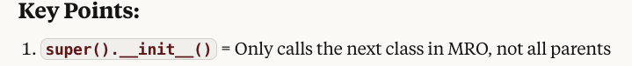

Decorator, class decorator-cls, basically update the class

static method you can pass in any parameter

without self，not belong to class or instances

这两种pass in parent class 都可以，一般用super().__init__(self,…)

self.prog_lang=prog_lang

Check if mgr is developers subclass

Check if mgr is developers instance

**self is Required in ALL Instance Methods**

**Rule:** Every method that belongs to a class (instance method) must have self as the first parameter, regardless of whether it uses instance variables or not.

